In or Out – What Do You Need to be Happy?
This activity is designed to be used from Year 1 upwards. You could easily create a similar activity for secondary school children, dropping the pictures to avoid being seen as patronising.
Each group has a set of cards, and a circle of rope, string or paper. They have to place inside the circle the things they think you need to have to be happy.
It may take some clarifying to get across the idea that this is not just about deciding which are nice things. You’re trying to find the smallest group of things someone has to have to be happy.
You could suggest starting with everything inside the circle, and then see if there are any things you could take out and still be happy.
Here are some possible follow-up questions:
Is there anything everyone agrees you need to be happy? Is there anything everyone thinks you don’t need?
Why did you decide ... was something you had to have to be happy? Your group thought differently. Why did you think you didn’t have to have ... to be happy?
Is there anything you can see another group have put differently that you would like to ask them about?
If you had to, is there any one thing you could take out of your circle and still be happy? If so, why did you choose that one?
If there were any, what were the “something elses” people need to be happy?
Is there anything the same about the things you need to be happy?
Is there anything the same about the things you don’t need to be happy?
Could you be unhappy even if you had all these things? How could that be?
Which out of all of the things you need to be happy is the most important?
Do you need all these things all the time?
Do you think your parents would have the same list?
Do you think you have the same list you had a year ago?
Do you think the pictures made any difference to the ones you chose?
Do you have to be smiling to be happy?
Can you be happy for a whole day, or just for a minute at a time?
Can you be happy when you’re sleeping?
Thinking - Can you be happy without knowing you’re happy?
Friends – Do you have to be with your friends to be happy, or is it enough to know you have friends?
Television – If you had never seen a television, would you be unhappy without it?
Holiday – If you were always on holiday, would it still be a holiday?
Play – if you did nothing but play, would it ever get boring?
love

friends
play
holiday
music
laughter
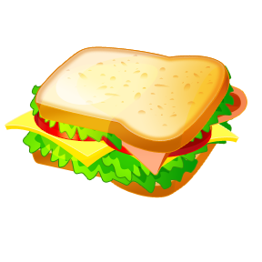

food
water
family
car
thinking
television
home
school

